**EE 746 Introduction to Neuromorphic Engineering**

**1.Leaky integrate and fire Model**

**a.** In the first subpart of the problem a steady state value of the membrane potential is needed to basically have a general idea of the variation of the membrane potential in the body.

We know from the leaky integrate and Fire model:

$$C\frac{dV}{dt}=-g{}_{l}\left(V\left(t\right)-E_{L}\right)+I_{app}\left(t\right)$$

As this is a simple differential equation and one that we are able to solve very easily**(given Iapp(t)=Io)** Where K is a constant.

$$V\left(t\right)=\frac{g{}_{L}E_{L}+I_{o}}{g_{L}}+Ke^{-\frac{g_{L}}{c}t}$$

Now at t=0 we have V(t)=EL . Thus we get K=-Io/gL

Thus the steady state value of Membrane Potential where t=infinity we get steady state of the membrane potential as

$V_{steady}=\frac{g_{L}E_{L}+I_{o}}{g_{L}}$

Now for the value of current we have the following formula

$$I=C\frac{dV}{dt}=I_{o}e^{\frac{-g_{L}}{c}t}$$

Now the neuron will spike only when $V>{ V}_{T}$. Thus , we get the time when this happens as

$$e^{-\frac{g_{L}}{C}t}=\frac{V_{T}-\frac{g_{L}E_{L}+I_{o}}{g_{L}}}{K}$$

Thus value of the steady state current is as under:

$$I_{C}=g_{L}E_{L}+I_{o}-g_{L}V_{T}$$

**b.**The code for the corresponding calculation for N neurons has been written MATLAB program named [**Problem_1B_EE746.m**](MATLAB/EE%20746/Assignment-I/Problem_1B_EE746.m) which simultaneously applies the principle of the Runge-Kutte Method on all neurons at once. The Only problem with this code however is that it has not been validated with data so at this juncture i am not sure about the accuracy of the code

The Runge Kutte Method has been applied with second order accuracy and one of the things to note about the whole process is the fact that M being too less and time t being too large will lead to large deviations from the correct numerical value of the answer.

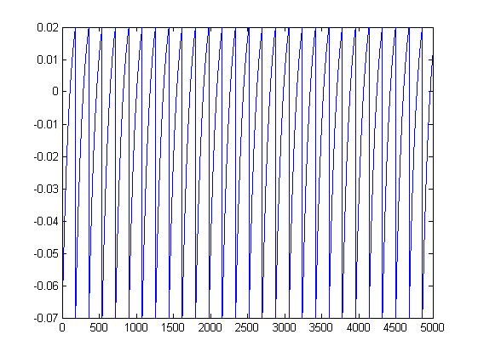

**c.** For IO =0 the value of IC in this case is the fact is as follows:

$$I_{C}=g_{L}E_{L}-g_{L}V_{T}$$

which is to be later solved to by a matlab code to give the following:

[MATLAB\EE 746\Assignment-I\Problem_1C_EE746.m](MATLAB/EE%20746/Assignment-I/Problem_1C_EE746.m)

The graph plotted was as under for 2,4,6,8 neuron

**2.**We have the differential equation of the model as under:

$$C\frac{dV}{dt}=k_{z}\left(V\left(t\right)-E_{r}\right)\left(V\left(t\right)-E_{t}\right)-U\left(t\right)+I_{app}\left(t\right)$$

$$\frac{dU}{dt}=a[b\left(V\left(t\right)-E_{r}\right)-U\left(t\right)]$$

**a.** Thus for the steady state model of the differential curve is when both the derivatives equal to 0.

Thus,

$$C\frac{dV}{dt}=0 =>k_{z}\left(V\left(t\right)-E_{r}\right)\left(V\left(t\right)-E_{t}\right)-U\left(t\right)=0$$

$$\frac{dU}{dt}=0 => a\left[b\left(V\left(t\right)-E_{r}\right)-U\left(t\right)\right]=0$$

Solving these two we get

V=Er or Et+b/kz

U=0 or b(Et+b/kz-Er)

**b.** The equivalent difference equation is as follows

$$V_{n+1}=V_{n}+{(k}_{z}\left(V\left(t_{n}\right)-E_{r}\right)\left(V\left(t_{n}\right)-E_{t}\right)-U\left(t_{n}\right))*∆t$$

$$U_{n+1}=U_{n}+\left( a\left[b\left(V\left(t_{n}\right)-E_{r}\right)-U\left(t{}_{n}\right)\right]\right)*∆t$$

**c.**

The Code for the same is as follows please have a look

[MATLAB\EE 746\Assignment-I\Problem_2C_EE746.m](MATLAB/EE%20746/Assignment-I/Problem_2C_EE746.m)

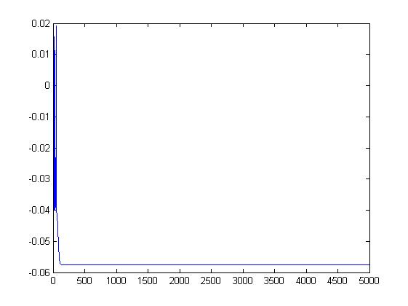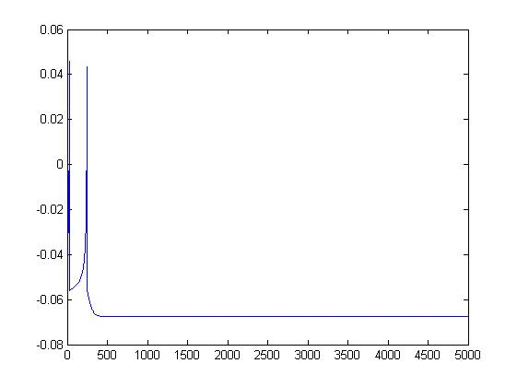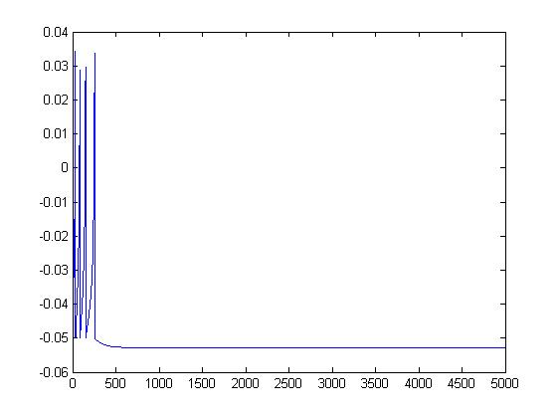

**3.**

**a** The equivalent difference equation as seen from (i) and (ii) is as follows:

$V_{n+1}=V_{n}+\left(-g_{L}\left(V\left(t_{n}\right)-E_{L}\right)+g_{L}∆_{T}exp\left(\frac{V\left(t_{n}\right)-V_{T}}{∆_{T}}\right)-U\left(t\right)+I_{app}\left(t_{n}\right) \right)*∆t$

$$U_{n+1}=U_{n}+\left(a\left[V\left(t_{n}\right)-E_{L}\right]-U\left(t_{n}\right)\right)*∆t$$

**b.** the code for this is as follows:

[MATLAB\EE 746\Assignment-I\Problem_3B_EE746.m](MATLAB/EE%20746/Assignment-I/Problem_3B_EE746.m)

V_steady =

-0.0445

-0.0460

-0.0461

U_steady =

1.0e-10 *

0.5090

0.4793

0.2388

the method used is **Newton Raphson's** method the solution for each type of neuron as under.

**c.** The code is as under:

[**MATLAB\EE 746\Assignment-I\Problem_3C_EE746.m**](MATLAB/EE%20746/Assignment-I/Problem_3C_EE746.m)

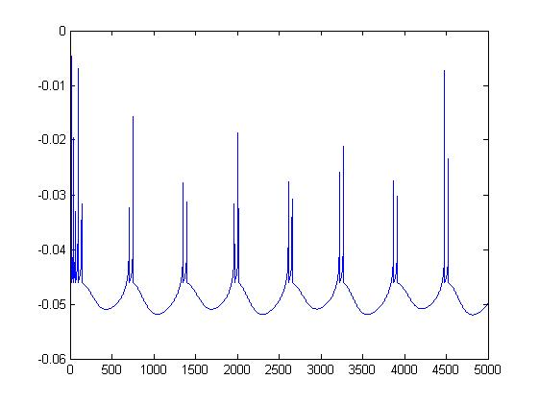

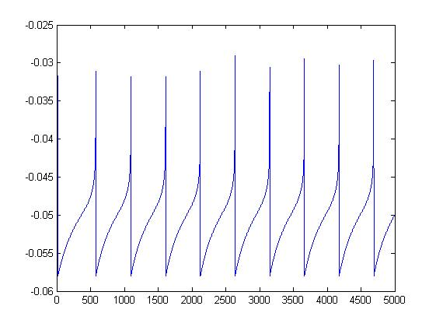

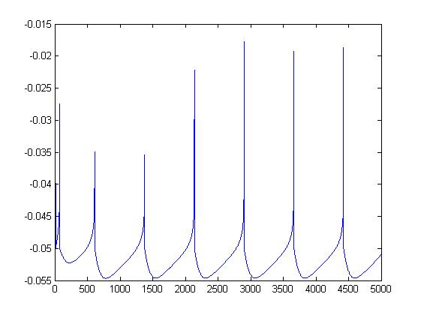

**4** Please find the code for the solution

[**MATLAB\EE 746\Assignment-I\Problem_4A_EE746.m**](MATLAB/EE%20746/Assignment-I/Problem_4A_EE746.m)